Printing Player/Coach Passes and Official Rosters
How to Print Passes
Only individuals with access to your club connect admin system and access to “Print Member Cards” can print passes. If someone needs to have access added, it can be down by the club official who has the primary access (usually the person who attended the US Soccer Connect on-boarding session).

To print passes, log in to your club connect admin system.

- Select desired team from file structure on left hand side of screen.
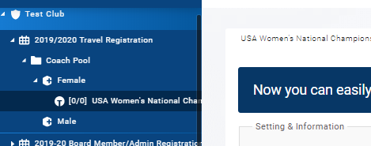

- Click Members on top of screen, then “Print Member Cards”
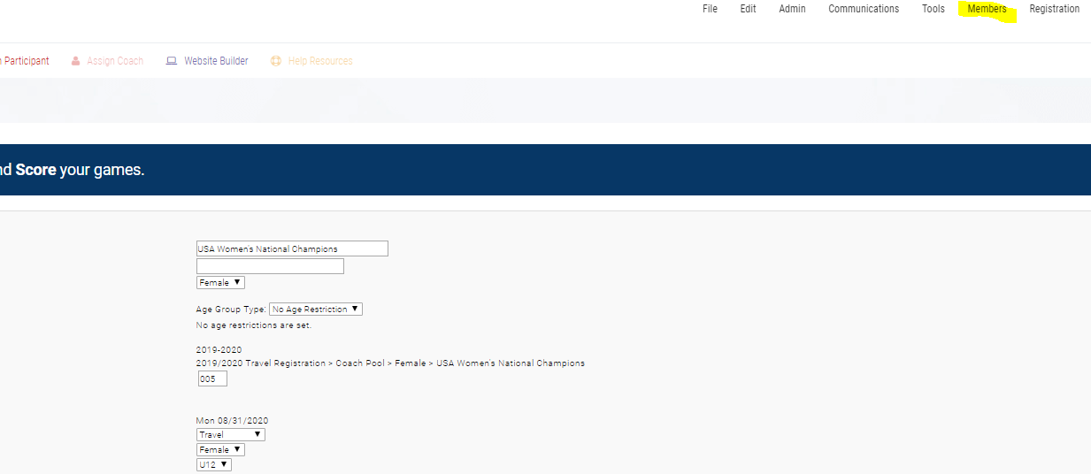

- Dialogue box will appear, select only choice “EPYSA Player Cards”, and click blue, Print button.

- A document will appear with all pass data. Only print passes on official Eastern Pennsylvania Youth Soccer Cardstock available from your travel league. All passes must be laminated.
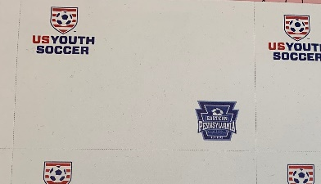
Sample Card Stock
How to Print Official Roster
To print official roster, log in to your club connect admin system.
- Select desired team from file structure on left hand side of the screen.

- Click Reports on top of screen, then Folders/Teams, then Admin Roster
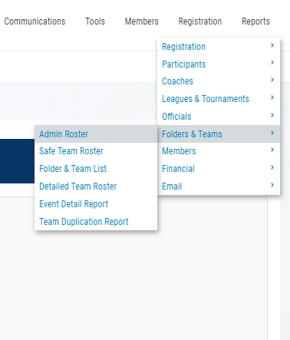

- Select “Eastern Pennsylvania Youth Soccer 2019/20 Official Roster”, Generate Roster (if you have a large roster, use condensed)

- The Official Roster has the State Logo in the right-hand corner with your club in red underneath.
