How to Print Rosters:
- Coaches and club admins have access to print approved rosters in GotSport. Login and select:
Team-Team Registrations-Correct League event>Blue Roster Button
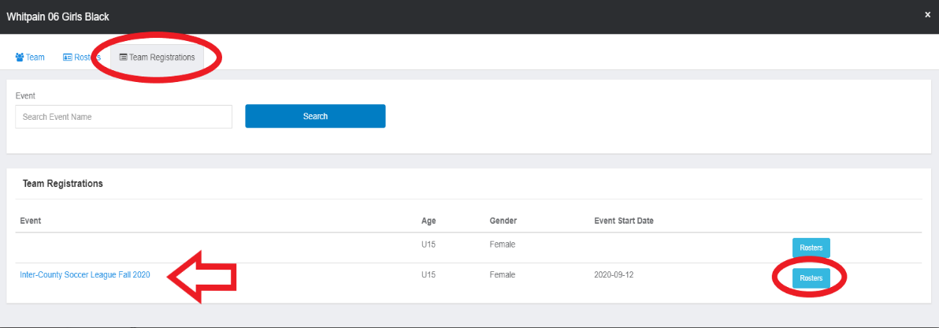
- On next screen, select Documents & IDS

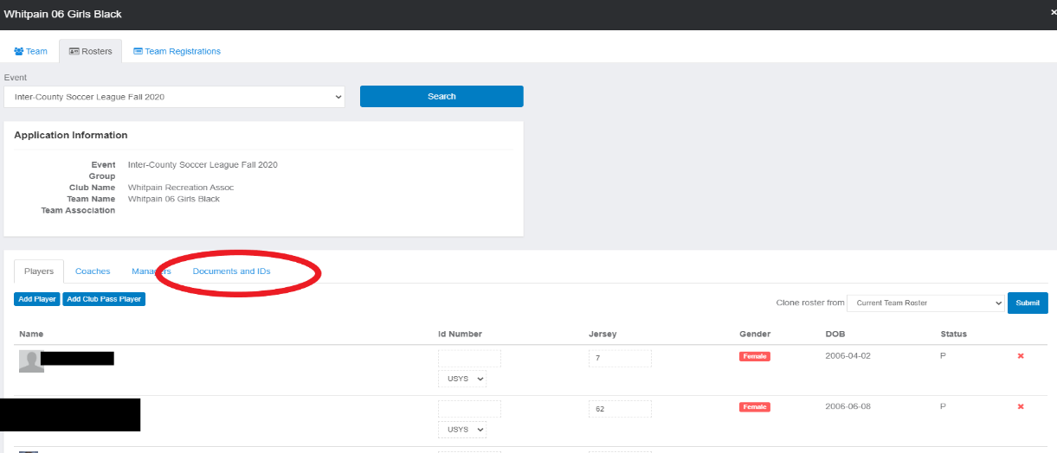

- On next screen, select the blue buttons Roster and ID Cards. Please note: Eastern Pennsylvania Youth Soccer is not requiring physical, laminated player passes. The Print ID cards are for tournament use only. The approved roster has photos. If your roster is blank—your team is not approved. Contact your league.
